Национальный Технический Университет Украины
«Киевский Политехнический Институт»
Факультет информатики и вычислительной техники
Кафедра вычислительной техники

Лабораторная работа №4
«Иследование принципов проектирования и работы динамического и статического планировщика»

Выполнил: студент ІІІ курса
группы ИВ-92
Петрук В.

Киев – 2012
Задание: составить модель пространственного планировщика на принципе не исключающего планирования (исследовать среднее время ожидания заявок).
Результаты работы программы:

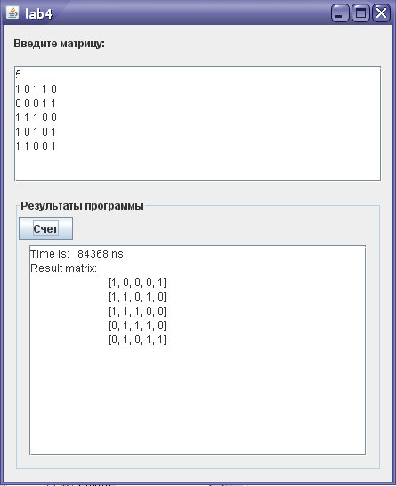

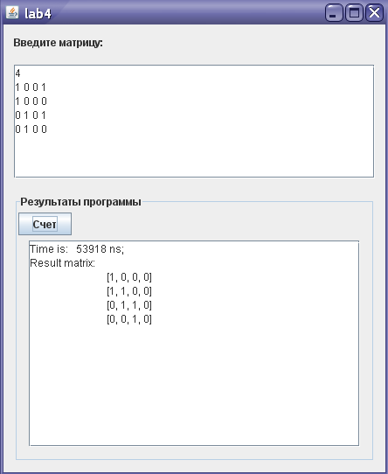
package Lab4;

import java.util.*;

public class L4 extends javax.swing.JFrame {

/** Creates new form MegaProga */
public L4() {
initComponents();
}
int[] columnNumber;
int[] rowNumber ;
private void calcMatrix() {
jTextArea2.setText("");
columnNumber = new int[n];
rowNumber = new int[n];
for (int i = 0; i < n; i++){
columnNumber[i] = i+1;
rowNumber[i] = i+1;
}
long start = System.nanoTime();
for (int k = 0; k < n; k++){
//long start = System.nanoTime();

int row = getMinRow(k);
exchangeRow(k, row);
int column = getMaxColumn(k);
exchangeColumn(k, column);
// long time = System.nanoTime() - start;
//jTextArea2.append(String.format("Time is: %7d ns; %d did %d\n", time, rowNumber[k], columnNumber[k]));
}

long time = System.nanoTime() - start;
jTextArea2.append(String.format("Time is: %7d ns; ", time));

jTextArea2.append("\nResult matrix:\n");
for (int i = 0; i < n; i++)
jTextArea2.append("\t" +Arrays.toString(matrix[i]) +"\n");
}

void exchangeElements(int[] mas, int i, int j){
int t = mas[i];
mas[i] = mas[j];
mas[j] =t;
}
void exchangeColumn(int first, int second){
if (first != second){
exchangeElements(columnNumber, first, second);
for (int i = 0; i < n; i++)
exchangeElements(matrix[i], first, second);
}
}
void exchangeRow(int first, int second){
if (first != second){
exchangeElements(rowNumber, first, second);
int[] temp = Arrays.copyOf(matrix[first],n);
matrix[first] = Arrays.copyOf(matrix[second],n);
matrix[second] = Arrays.copyOf(temp,n);
}
}

private int getMaxColumn(int k) {
int cnt = 0;
int index = k;
for (int j = k; j < n; j++){
int currentCnt = 0;
if (matrix[k][j] != 0)
for (int i = k; i < n; i++)
if (matrix[i][j] != 0)
currentCnt++;
if (currentCnt > cnt){
cnt = currentCnt;
index = j;
}
}
return index;
}

private int getMinRow(int k) {
int cnt = n;
int index = k;
for (int i = k; i < n; i++){
int currentCnt = 0;
for (int j = k; j < n; j++)
if (matrix[i][j] != 0)
currentCnt++;
if (currentCnt < cnt){
cnt = currentCnt;
index = i;
}
}
return index;
}

private void initComponents() {

jScrollPane1 = new javax.swing.JScrollPane();
jTextArea1 = new javax.swing.JTextArea();
jLabel1 = new javax.swing.JLabel();
jPanel1 = new javax.swing.JPanel();
jScrollPane2 = new javax.swing.JScrollPane();
jTextArea2 = new javax.swing.JTextArea();
jButton1 = new javax.swing.JButton();

setDefaultCloseOperation(javax.swing.WindowConstants.EXIT_ON_CLOSE);
setTitle("lab4");

jTextArea1.setColumns(20);
jTextArea1.setRows(5);
jScrollPane1.setViewportView(jTextArea1);

jLabel1.setText("Введите матрицу:");

jPanel1.setBorder(javax.swing.BorderFactory.createTitledBorder("Результаты программы"));

jTextArea2.setColumns(20);
jTextArea2.setEditable(false);
jTextArea2.setRows(5);
jScrollPane2.setViewportView(jTextArea2);

jButton1.setText("Счет");
jButton1.addActionListener(new java.awt.event.ActionListener() {
public void actionPerformed(java.awt.event.ActionEvent evt) {
jButton1ActionPerformed(evt);
}
});

javax.swing.GroupLayout jPanel1Layout = new javax.swing.GroupLayout(jPanel1);
jPanel1.setLayout(jPanel1Layout);
jPanel1Layout.setHorizontalGroup(
jPanel1Layout.createParallelGroup(javax.swing.GroupLayout.Alignment.LEADING)
.addGroup(jPanel1Layout.createSequentialGroup()
.addGroup(jPanel1Layout.createParallelGroup(javax.swing.GroupLayout.Alignment.LEADING)
.addComponent(jButton1)
.addGroup(jPanel1Layout.createSequentialGroup()
.addContainerGap()
.addComponent(jScrollPane2, javax.swing.GroupLayout.DEFAULT_SIZE, 379, Short.MAX_VALUE)))
.addContainerGap())
);
jPanel1Layout.setVerticalGroup(
jPanel1Layout.createParallelGroup(javax.swing.GroupLayout.Alignment.LEADING)
.addGroup(jPanel1Layout.createSequentialGroup()
.addComponent(jButton1)
.addPreferredGap(javax.swing.LayoutStyle.ComponentPlacement.RELATED)
.addComponent(jScrollPane2, javax.swing.GroupLayout.DEFAULT_SIZE, 236, Short.MAX_VALUE)
.addContainerGap())
);

javax.swing.GroupLayout layout = new javax.swing.GroupLayout(getContentPane());
getContentPane().setLayout(layout);
layout.setHorizontalGroup(
layout.createParallelGroup(javax.swing.GroupLayout.Alignment.LEADING)
.addGroup(javax.swing.GroupLayout.Alignment.TRAILING, layout.createSequentialGroup()
.addContainerGap()
.addGroup(layout.createParallelGroup(javax.swing.GroupLayout.Alignment.TRAILING)
.addComponent(jPanel1, javax.swing.GroupLayout.Alignment.LEADING, javax.swing.GroupLayout.DEFAULT_SIZE, javax.swing.GroupLayout.DEFAULT_SIZE, Short.MAX_VALUE)
.addComponent(jLabel1, javax.swing.GroupLayout.Alignment.LEADING)
.addComponent(jScrollPane1, javax.swing.GroupLayout.Alignment.LEADING, javax.swing.GroupLayout.DEFAULT_SIZE, 413, Short.MAX_VALUE))
.addContainerGap())
);
layout.setVerticalGroup(
layout.createParallelGroup(javax.swing.GroupLayout.Alignment.LEADING)
.addGroup(layout.createSequentialGroup()
.addContainerGap()
.addComponent(jLabel1)
.addGap(18, 18, 18)
.addComponent(jScrollPane1, javax.swing.GroupLayout.PREFERRED_SIZE, 130, javax.swing.GroupLayout.PREFERRED_SIZE)
.addGap(18, 18, 18)
.addComponent(jPanel1, javax.swing.GroupLayout.DEFAULT_SIZE, javax.swing.GroupLayout.DEFAULT_SIZE, Short.MAX_VALUE)
.addContainerGap())
);

pack();
}// </editor-fold>//GEN-END:initComponents

private void jButton1ActionPerformed(java.awt.event.ActionEvent evt) {//GEN-FIRST:event_jButton1ActionPerformed
String inputData = jTextArea1.getText();
scanData(new Scanner(inputData));
calcMatrix();
}//GEN-LAST:event_jButton1ActionPerformed

/**
* @param args the command line arguments
*/
public static void main(String args[]) {
java.awt.EventQueue.invokeLater(new Runnable() {
public void run() {
new L4().setVisible(true);
}
});
}

int[][] matrix;
int n;
// Variables declaration - do not modify//GEN-BEGIN:variables
private javax.swing.JButton jButton1;
private javax.swing.JLabel jLabel1;
private javax.swing.JPanel jPanel1;
private javax.swing.JScrollPane jScrollPane1;
private javax.swing.JScrollPane jScrollPane2;
private javax.swing.JTextArea jTextArea1;
private javax.swing.JTextArea jTextArea2;
// End of variables declaration//GEN-END:variables

private void scanData(Scanner scanner) {
n = scanner.nextInt();
matrix = new int[n][n];
for (int i = 0; i < matrix.length; i++)
for (int j = 0; j < matrix[i].length; j++){
matrix[i][j] = scanner.nextInt();
System.out.println(Arrays.toString(matrix[i]));
}
}

}

